Lesson 3 Homework | LT 2.1, 2.2, 2.3 | 3, 6, 9, 11, 13-21 all (FRONT PAGE)  3, 4, 6, 7, 9, 11, 12 (BACK PAGE)

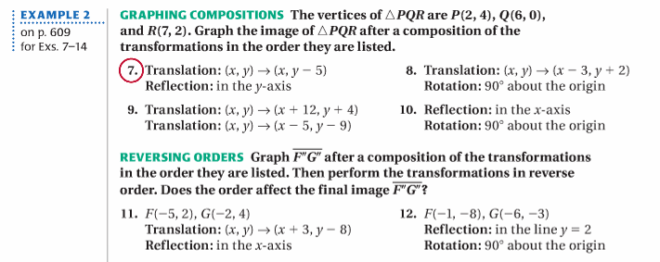

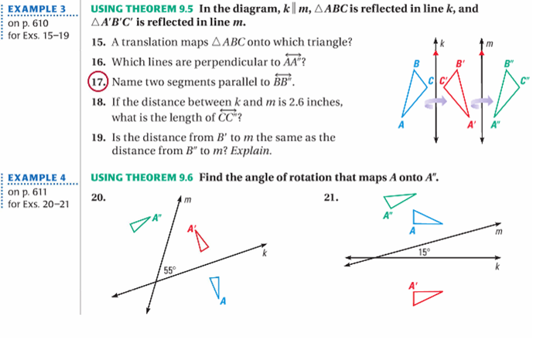

Lesson 3 Homework | LT 2.1, 2.2, 2.3 | 3, 6, 9, 11, 13-21 all (FRONT PAGE)  3, 4, 6, 7, 9, 11, 12 (BACK PAGE)

